

**Task 2: Connecting and analysing the various results – Gate Transformer and Space-movement correlation analysis**

**Description**

This exercise introduces the Gate Transformer tool and the QGIS spatial join functions to produce a simple space-movement correlation analysis. This exercise requires the pedestrian count dataset, the Axial map segment analysis dataset and the Catchment network dataset from the previous exercise.

1. **Prepare the project**
   1. Make the **pedestrian_counts** layer visible
   2. Make the **Axial_map_segment_analysis** layer visible
   3. Make the **Catchment_network_line** layer visible
2. **Run Gate Transformer – Resize**
   1. The aim of this step is to resize the movement gates so it has a constant length for visualisation
   2. Start the **Gate transformer** tool by clicking on the gate transformer button or go to **SSToolkit** -> **Gate Transformer**
   3. Select the **pedestrian_counts** layer
   4. Click on the **resize line** radio button
   5. Set the length to "25" metres
   6. Click **Transform** and click **Toggle Edit** to save edits.
   7. This resizes the movement gates to the same length of "25" metres

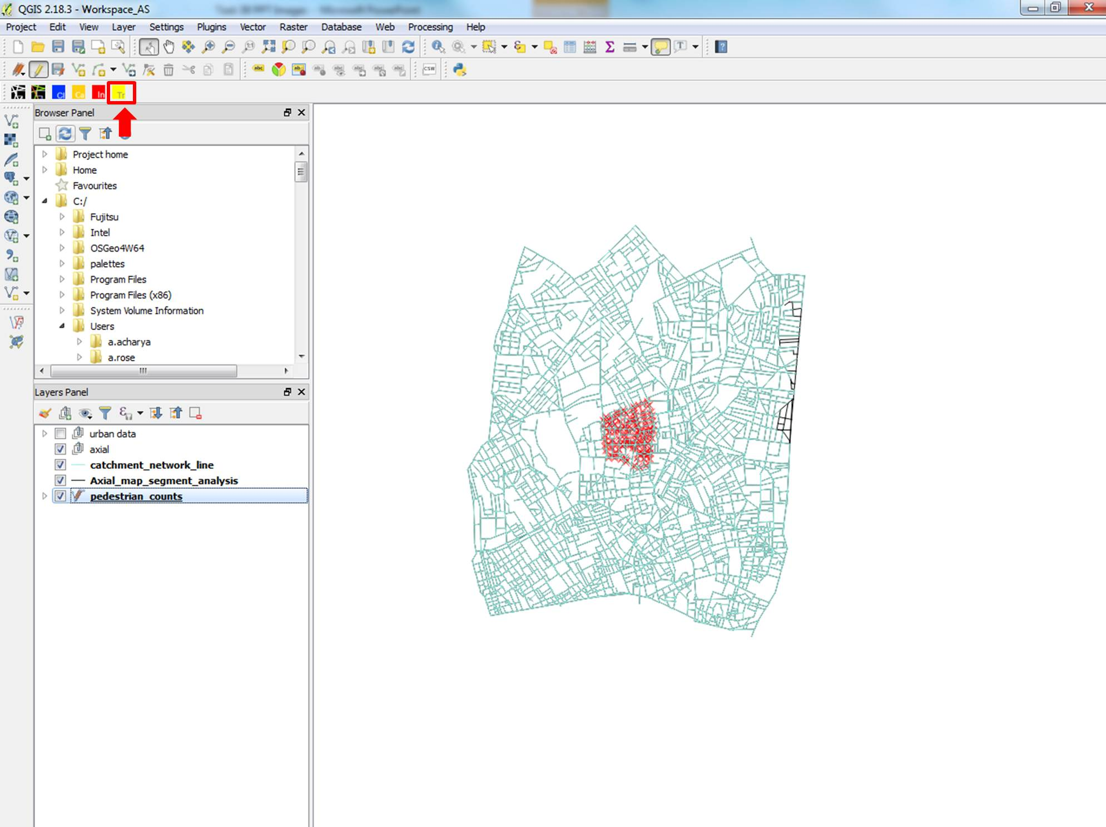

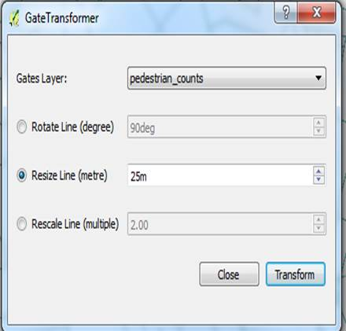

1. **Visualise the Pedestrian counts layer**
   1. Start the **Attributes Explorer** SST tool
   2. Select the **pedestrian_counts** layer
   3. Select the **“PEDMOV”** attribute
   4. Select **Symbology** tab
   5. Set colour range as **“Classic”**
   6. Increase the line width to 0.5
   7. Set Intervals to ‘**Equal Intervals**’
   8. Click the **Apply Symbology** button
   9. This is the standard display for the pedestrian movement data
   10. You can add arrows by going to the **‘Style’** panel of the layer
   11. Save an image of the map window

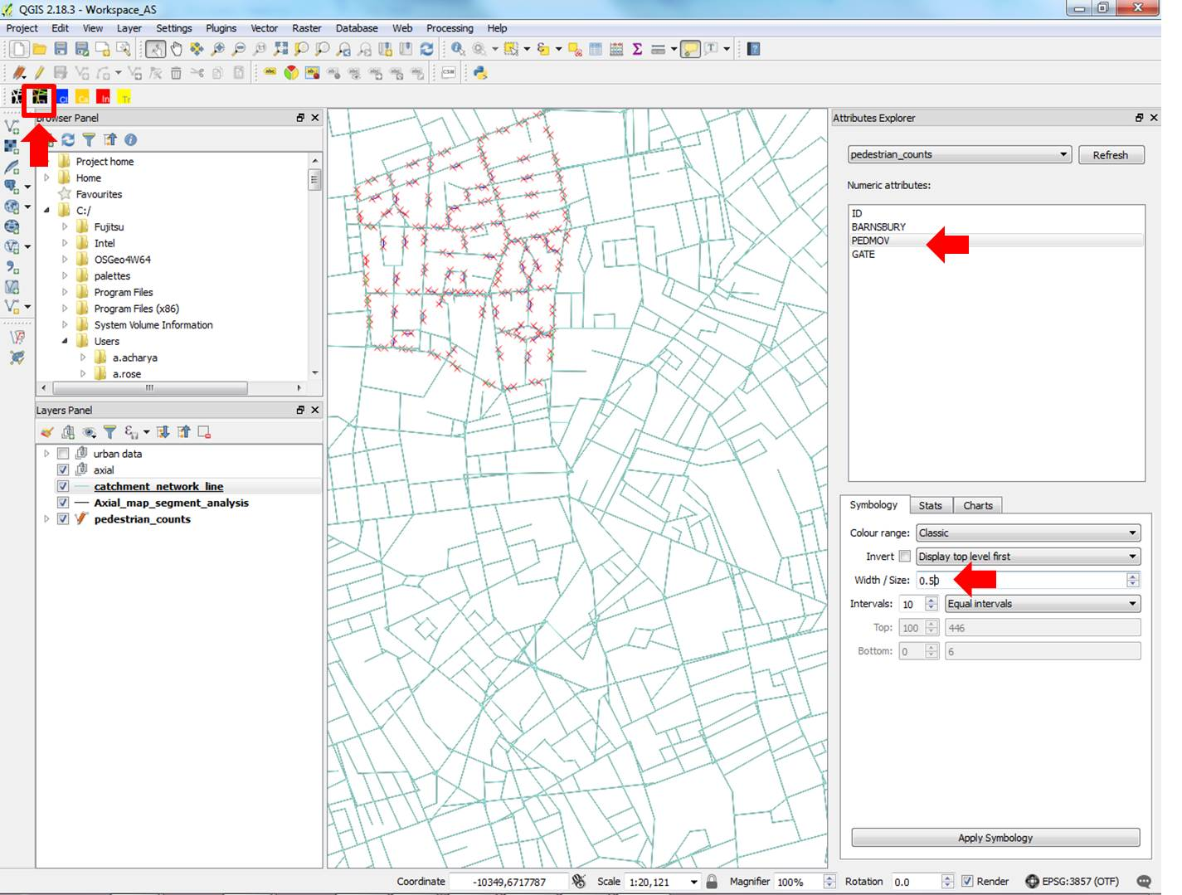

1. **Run Gate Transformer - Rotate**
   1. The aim of this step is to rotate the movement gates so it intersects with the segment layer
   2. Start the **Gate transformer** tool by clicking on the gate transformer button or go to **SSToolkit** ->**Gate Transformer**
   3. Select the **pedestrian_counts** layer
   4. Click on the **rotate** radio button
   5. Set the angle at **“90deg”**
   6. Click **Transform**
   7. The gates are now rotated by "90" degrees.
   8. If the gates do not intersect with the segment layer, rotate again with a different angle until it intersects
   9. Make sure the gates intersect the correct corresponding segment

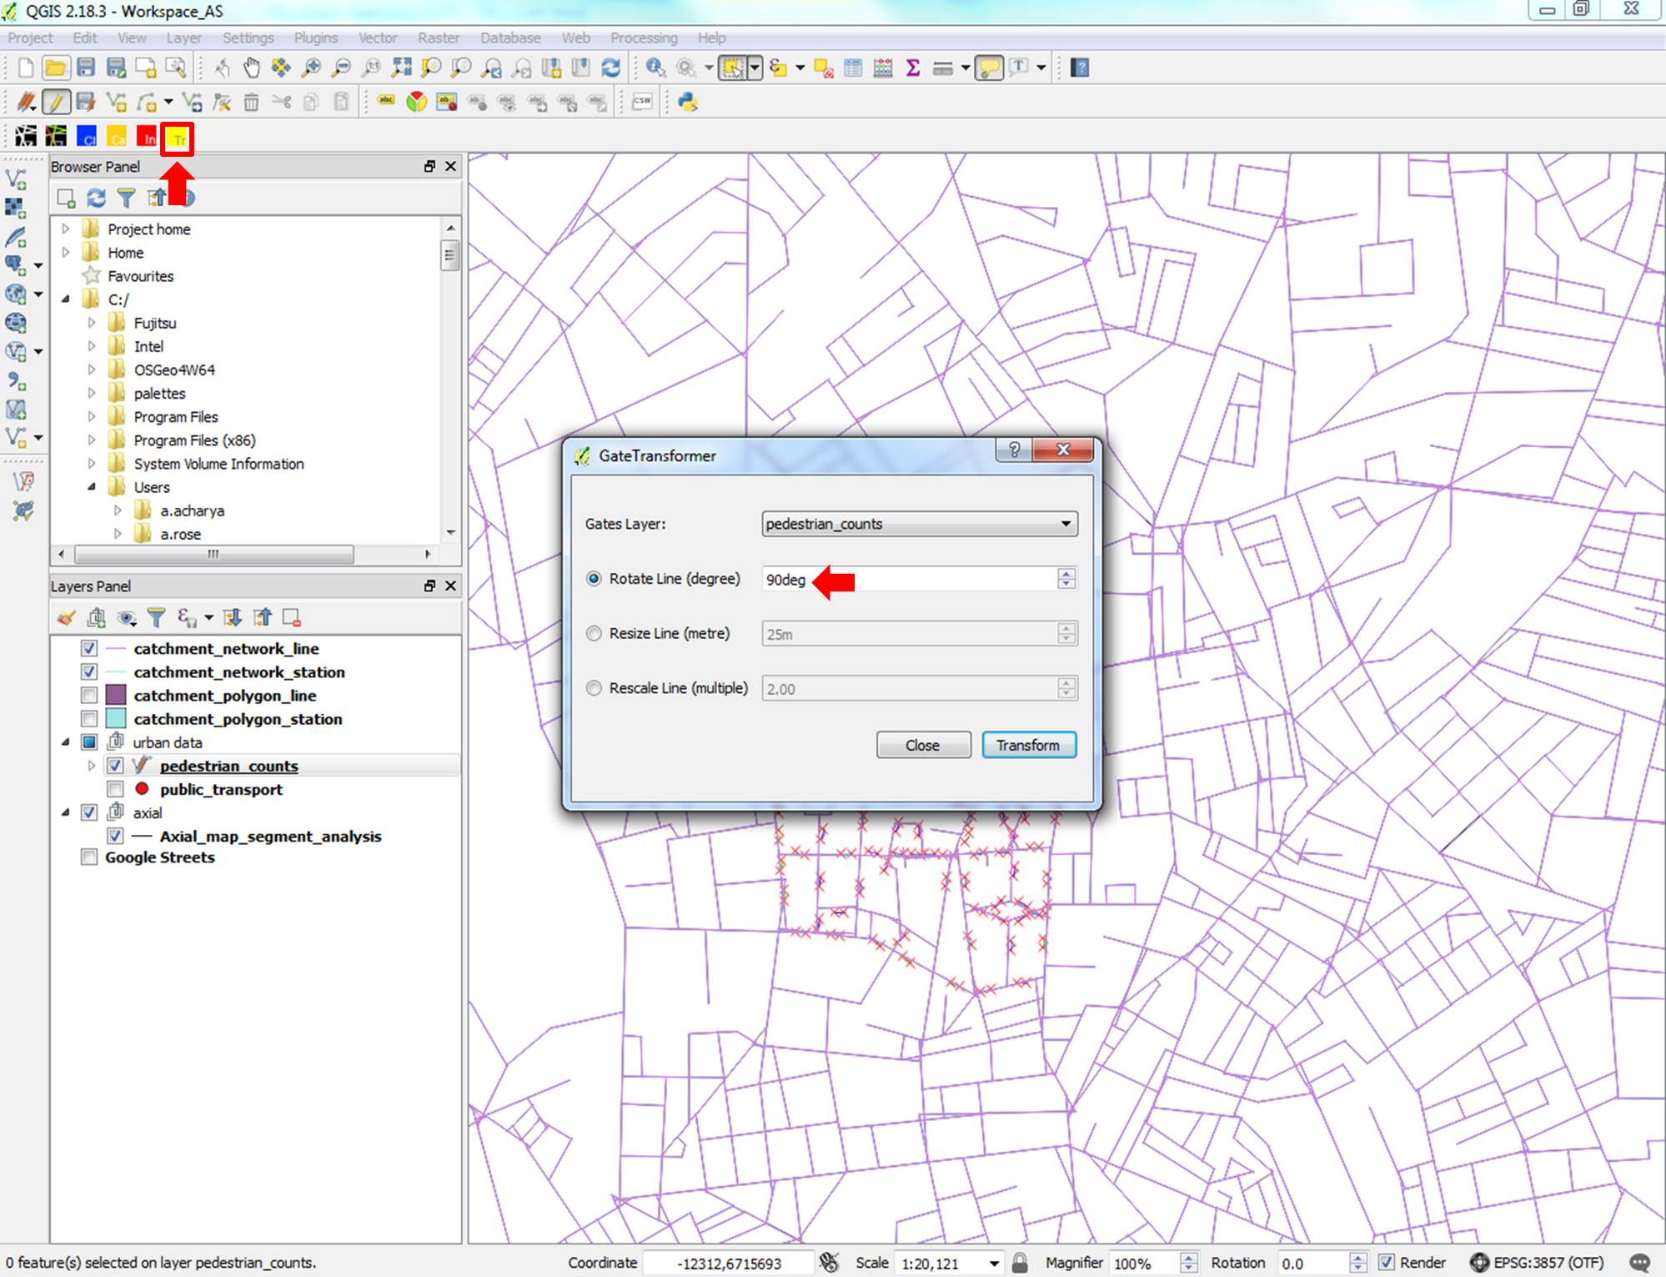

1. **Pedestrian count gate and space syntax measures spatial join**
   1. The aim of this step is to join the **pedestrian_count** gate data layer and the **Axial_map_segment_analysis** layer
   2. Go to the **Vector** menu at the top ->**Data management tool** -> **Join attributes by location**
   3. Select the **pedestrian_counts** layer as **Target vector layer**
   4. Select the **Axial_map_segment_analysis** layer as **Join vector layer**
   5. Check the **intersect** button
   6. Leave the other parameters as default
   7. Press **run** to create a temporary joined layer
   8. The temporary layer contains both the movement data and the space syntax measures where the two intersect

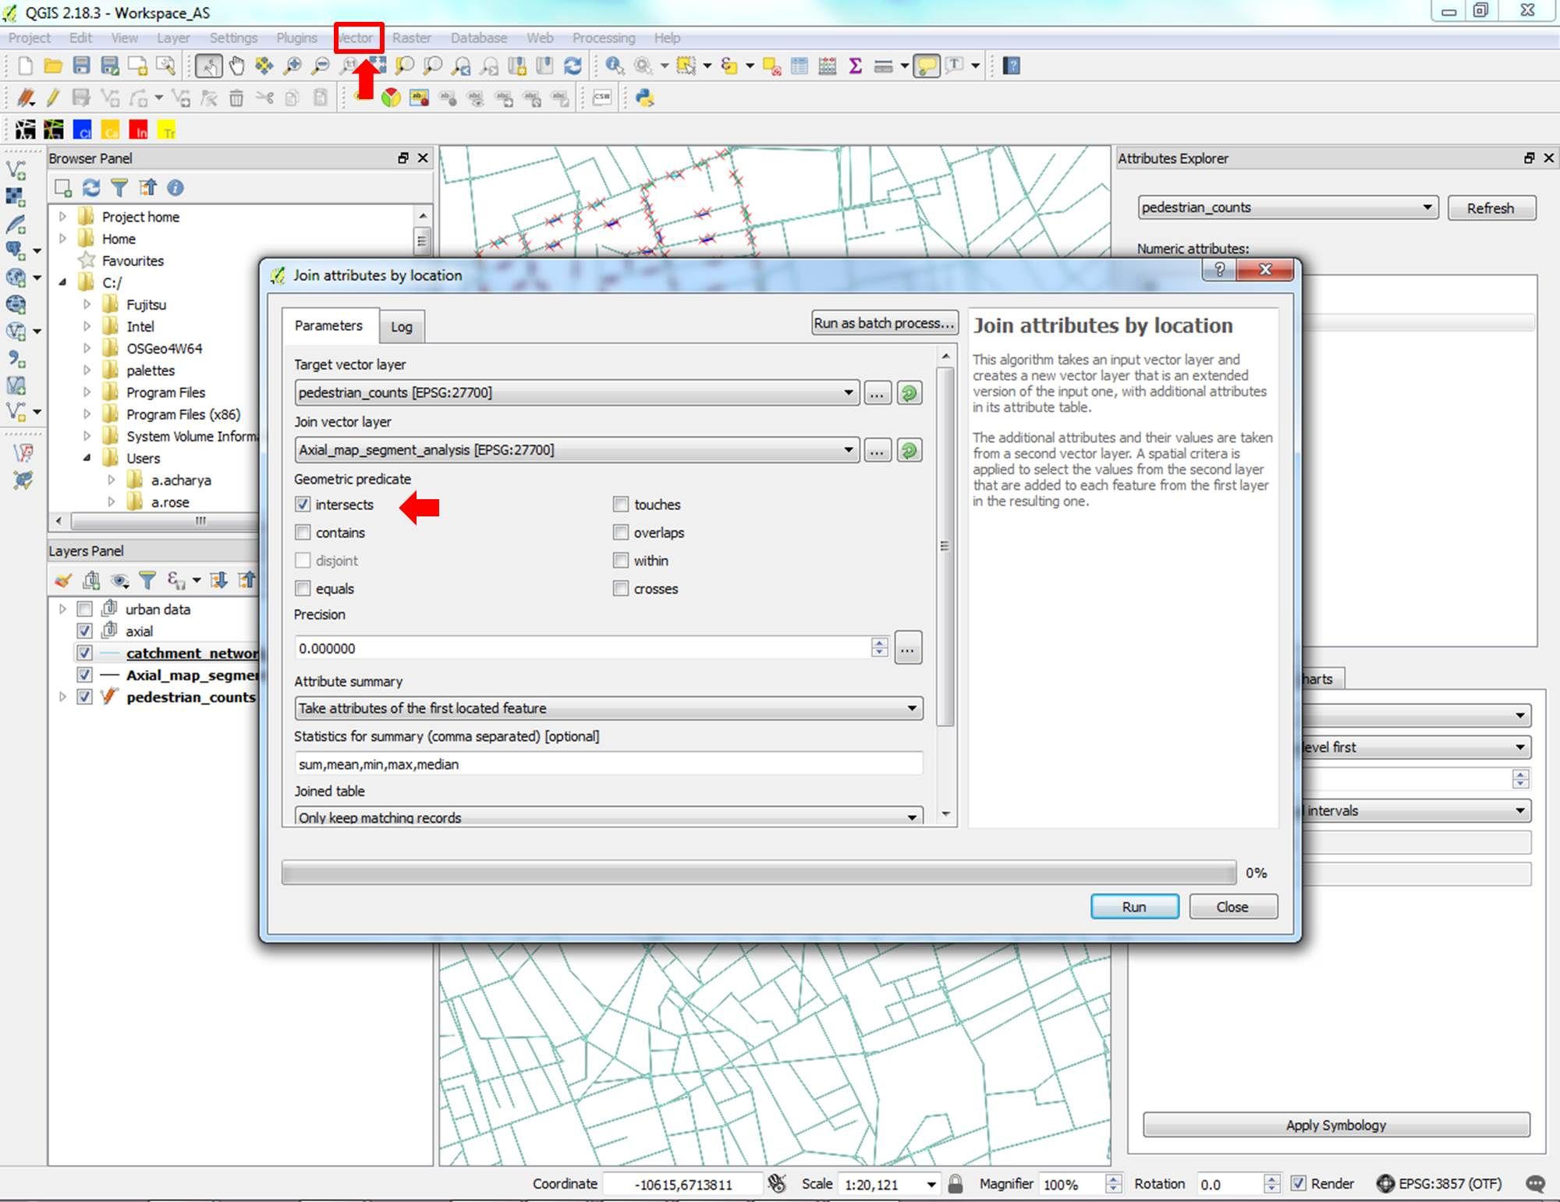

1. **Pedestrian count gate and catchment analysis spatial join**
   1. The aim of this step is to join the pedestrian counts gate data layer and the catchment analysis map
   2. Go to the **Vector** menu at the top -> **Data management tools** -> **Join attributes by location**
   3. Select the **pedestrian_counts** layer as **Target vector layer**
   4. Select the **catchment_network_line** layer as **Join vector layer**
   5. Check the **intersect** button
   6. Leave the other parameters as default
   7. Press **run** to create a temporary joined layer
   8. The temporary layer shows both the movement data and the distance to tube stations where the two intersect

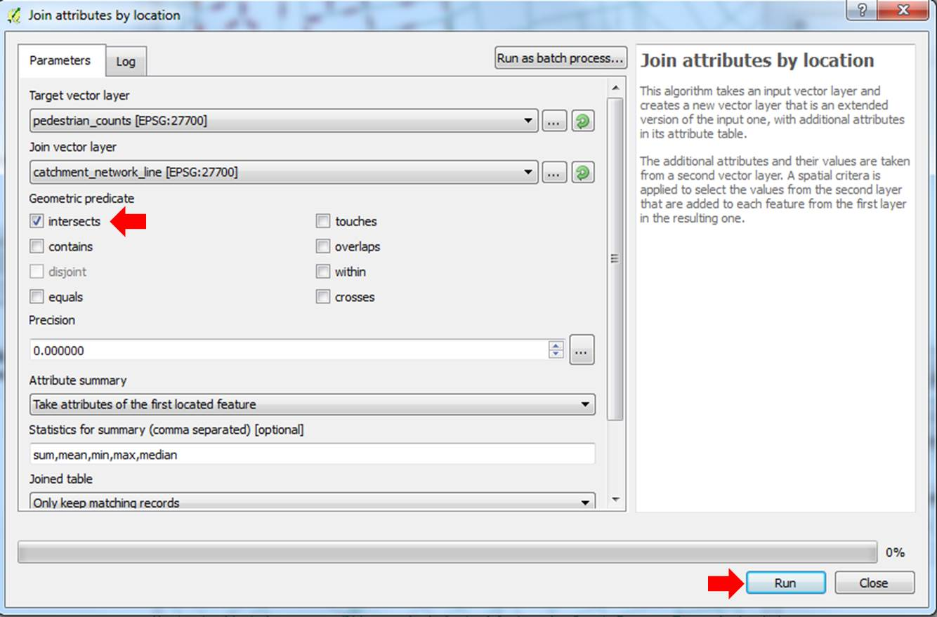

1. **Convert the PEDMOV column in the new joined layers from “string” to “integer” format**
   1. Double click on new **Joined layer** to get layer properties box
   2. Select **Fields** tab
   3. Click on the **Field calculator** button (abacus sign)
   4. Check the **Create New Field** box
   5. Type “**PEDMOV_num**” as **Output field Name**
   6. Check that “**Whole number (integer)”** is selected in **Output field type**
   7. In the Expression box,under row_number, select **Conversions** and double click on **“to_int”** from the drop-down menu
   8. Now select **Fields and Values** and double click on **“PEDMOV”**
   9. In the expression box to the left, add a **“)”** (close the bracket). The expression should now read: **to_int(“PEDMOV”)**
   10. Click **OK.** You will see that a new **“PEDMOV_Num”** column has been added to your attribute table
   11. Repeat step 7 for your other new **Joined layer,** so that you have **PEDMOV_num** intergercolumns in both **Joined layers**
   12. Save both **Joined layers** as Shapefiles (otherwise they will be lost as Joined layers are temporary layers)

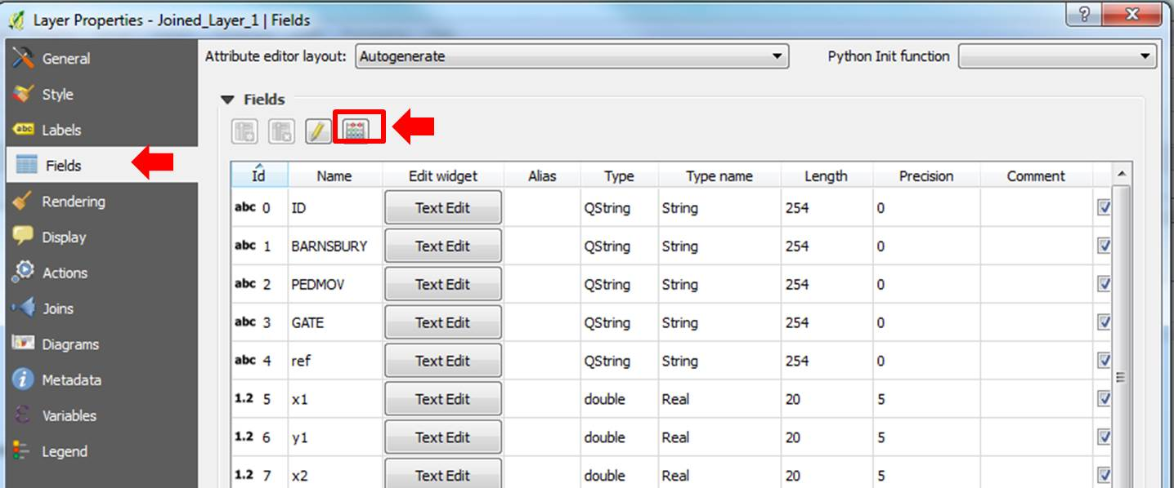

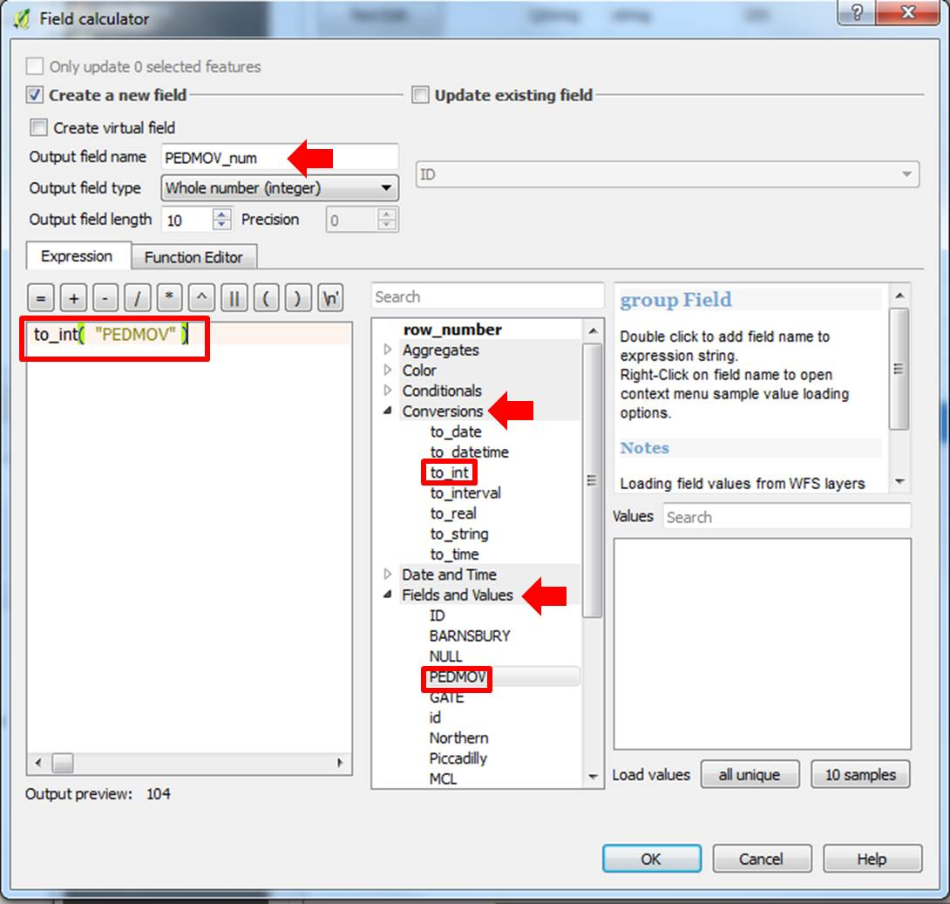

1. **Statistical scatterplot analysis of two variables**
   1. Start the **Attributes Explorer** SST tool
   2. Select one of the newly saved **Joined layer**
   3. Select **Charts** tab
   4. Select **Scatter plot** button
   5. Under **numeric attributes** or X-axis, select **"INT"** (or the name of a tube station)
   6. Under **Y-axis**, select **"PEDMOV_num"**
   7. The scatterplot shows the regression line, the equation of the line and the **r2** (goodness of fit)

